Deep State Dupes
June 8th, 2020

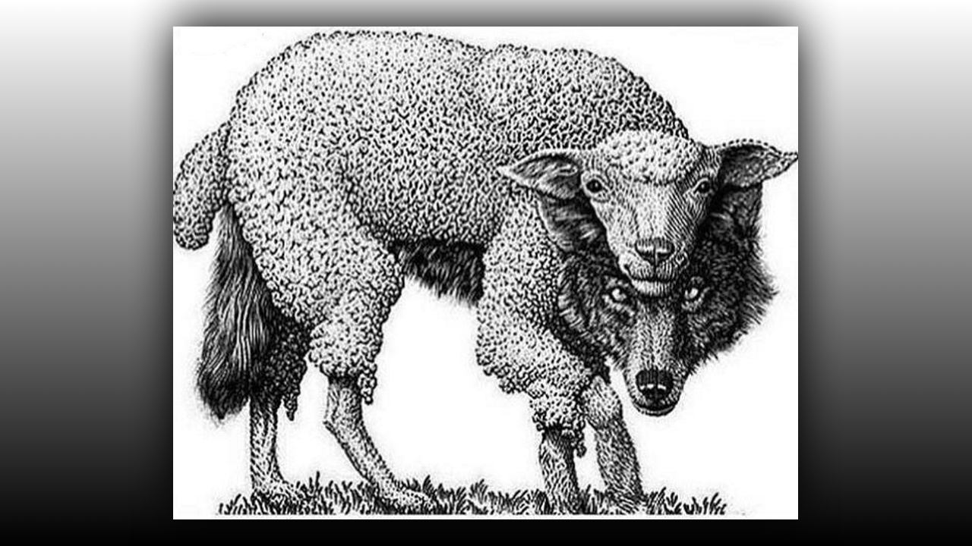
The Lord bless you dear Heartdwellers, I really felt the need to share something with you about the current events. Dear ones, please do not become deep state dupes. All this rioting has been deliberately orchestrated by evil people intent on destroying our country. Please, please go deeper in your discernment and don’t be lured into this false flag. What is a false flag?

A false flag is a covert operation designed to deceive; the deception creates the appearance of a particular party, group, or nation being responsible for some activity, disguising the actual source of responsibility.

It comes as no surprise to those who look beyond the face of biased mainstream media…many of these people are CIA operatives that deliberately slant and distort to influence public opinion against our constitution and the freedoms Trump has so fearlessly defended.

Please, African Americans, don’t be duped by this Hollywood styled event. The man supposedly who was killed, worked side by side for 17 years with the cop that supposedly killed him. They can be seen working together at the Sandy Hook false flag where children appeared to be killed, but since then journalists have dug up evidence that they are alive and well and in their teens right now.

Dear ones, because so many of their sources for adrenochrome have been destroyed the enemies of God are getting desperate to unseat Trump. Democratic mayors of big cities are allowing looting and shooting and doing nothing about it. The Minneapolis mayor just announced that he was slashing the police force. Why would they do this in a time where public safety should be the number one concern?

They want our president to declare martial law so they can try to impeach him. They are working overtime trying to assassinate him. Boy I hear about so many attempts I don’t share it with you but our source in the military tells me about these things. They want to assassinate him and they haven’t been able to because God is protecting him and because he is systematically destroying their infrastructure. The evil ones infrastructure with the wars going on underground. When you see an earthquake that’s between 4.5 and 5.6 you can pretty much be sure, on our continent in any case, that underground DUMB (deep underground military base) bases, the underground bunkers have been destroyed. This is where they have kidnapped children and using them for experiments and there is also a demon alien population attached to this and they crave human flesh. This is nothing new by the way, you can find out from many Native Americans what the Sky people were like. They are actually very, very treacherous, and when they say Sky people that is like the saucers that they engrave on the side of rocks and that kind of thing where you find pictographs that show they have been here before. So aside from the underground freeways and the underground connections there is a tremendous amount of warfare going on underneath right now. Underneath our nation and we are winning! We are winning, and the deep state is desperate to unseat our President, not to get him re-elected. They want to declare martial law so they can impeach him.

Please dear ones, don’t be lured into this mess and please spread the word that this is another false flag to destroy and divide our nation. Lord, have you anything to say?

My people, turn to Me in prayer. And Mother Clare is right, your government is being divided by evil people pretending to be on the side of the people, however they are the devil’s henchmen. Guns for hire with no sense of morality, going wherever they are paid to go, enact events that are pre-planned and timed to cause anarchy and divide the nation and to unseat your president.

He continued, drop to your knees, pray for your nation and refuse to be a part of this dividing force. Do not allow yourselves to be manipulated by mainstream media. Rather seek Me and My will and speak the truth to those who are acting out of ignorance and rage.

You must take a stand for your president and refuse to allow evil people to sway you. This country has made tremendous strides against discrimination, although it is not perfect, you will always have those who are closed minded and do not understand that I created all men equally.

Pray for your nation, pray the Divine Mercy Chaplet and spread the word that things are not as they seem, you must pray and go deeper in your discernment and support your president who is doing the right thing under tremendous pressure, despite the lies the evil ones are spreading. Dear ones, go deeper, do not allow yourselves to be manipulated. Cleave to Me, pray for your president, pray for your nation and share with your brothers and sisters that this is all an act that is being instigated to divide and ruin this country. I am with you; I am with you. I hear your prayers, they are powerful. Keep praying, keep praying for your nation.

